Server-to-Server Migration

🌟 Definition
# Source: AI Source: Provided by: [Data Path: Persons Table -> ID Column: 1, Name_En Column: Motasem Essam] -> From: [ChatGPT] on [6/7/2026]
Server-to-Server Migration is the process of moving applications, services, data, configurations, or entire workloads from one server to another server.
The source and destination servers can be:
- Physical → Physical
- Physical → Virtual
- Virtual → Virtual
- Physical → Cloud
- Cloud → Cloud
- Virtual → Cloud
Because of this, Server-to-Server Migration is a broad category that includes several server migration types.

🎯 Purpose
# Source: AI Source: Provided by: [Data Path: Persons Table -> ID Column: 1, Name_En Column: Motasem Essam] -> From: [ChatGPT] on [6/7/2026]
Organizations perform server-to-server migration to:
- Upgrade infrastructure
- Replace old servers
- Improve performance
- Increase capacity
- Move to cloud environments
- Improve security
- Reduce operational costs

🧠 Simple Definition
# Source: AI Source: Provided by: [Data Path: Persons Table -> ID Column: 1, Name_En Column: Motasem Essam] -> From: [ChatGPT] on [6/7/2026]
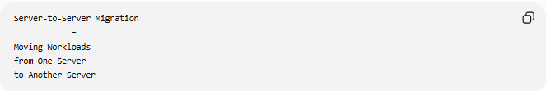
Server-to-Server Migration
=
Moving Workloads
from One Server
to Another Server

📚 What Can Be Migrated?
# Source: AI Source: Provided by: [Data Path: Persons Table -> ID Column: 1, Name_En Column: Motasem Essam] -> From: [ChatGPT] on [6/7/2026]
A server migration may include:
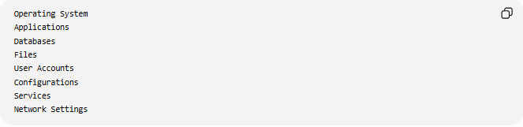
Operating System
Applications
Databases
Files
User Accounts
Configurations
Services
Network Settings

🔍 General Migration Flow
# Source: AI Source: Provided by: [Data Path: Persons Table -> ID Column: 1, Name_En Column: Motasem Essam] -> From: [ChatGPT] on [6/7/2026]
Source Server
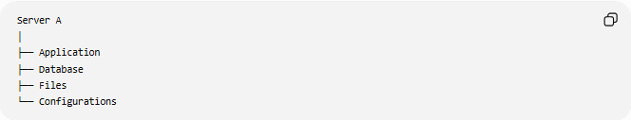
Server A
│
├── Application
├── Database
├── Files
└── Configurations
↓
Destination Server
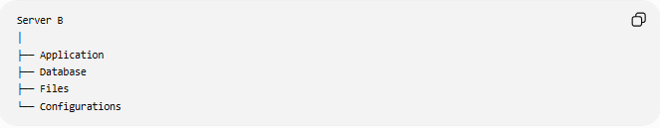
Server B
│
├── Application
├── Database
├── Files
└── Configurations

🏗️ Common Types of Server-to-Server Migration

1️⃣ Physical → Physical (P2P)
# Source: AI Source: Provided by: [Data Path: Persons Table -> ID Column: 1, Name_En Column: Motasem Essam] -> From: [ChatGPT] on [6/7/2026]
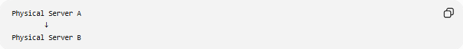
Physical Server A
↓
Physical Server B
Use cases:
- Hardware replacement
- Data center relocation
- Capacity upgrades

2️⃣ Physical → Virtual (P2V)
# Source: AI Source: Provided by: [Data Path: Persons Table -> ID Column: 1, Name_En Column: Motasem Essam] -> From: [ChatGPT] on [6/7/2026]
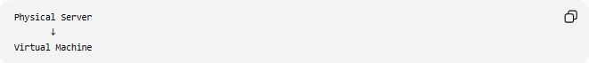
Physical Server
↓
Virtual Machine
Use cases:
- Server consolidation
- Virtualization projects

3️⃣ Virtual → Virtual (V2V)
# Source: AI Source: Provided by: [Data Path: Persons Table -> ID Column: 1, Name_En Column: Motasem Essam] -> From: [ChatGPT] on [6/7/2026]
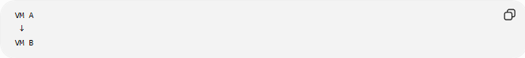
VM A
↓
VM B
Use cases:
- Hypervisor upgrades
- Infrastructure modernization

4️⃣ Physical → Cloud (P2C)
# Source: AI Source: Provided by: [Data Path: Persons Table -> ID Column: 1, Name_En Column: Motasem Essam] -> From: [ChatGPT] on [6/7/2026]
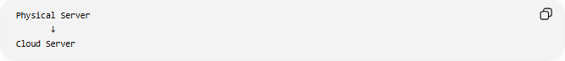
Physical Server
↓
Cloud Server
Use cases:
- Cloud adoption
- Data center exit

5️⃣ Cloud → Cloud (C2C)
# Source: AI Source: Provided by: [Data Path: Persons Table -> ID Column: 1, Name_En Column: Motasem Essam] -> From: [ChatGPT] on [6/7/2026]
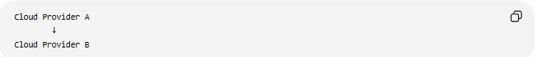
Cloud Provider A
↓
Cloud Provider B
Example:
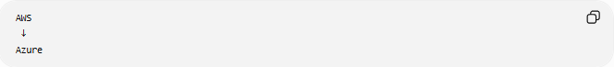
AWS
↓
Azure

6️⃣ Virtual → Cloud (V2C)
# Source: AI Source: Provided by: [Data Path: Persons Table -> ID Column: 1, Name_En Column: Motasem Essam] -> From: [ChatGPT] on [6/7/2026]
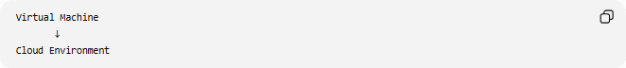
Virtual Machine
↓
Cloud Environment
Use cases:
- Cloud modernization
- Infrastructure scaling

🛠️ Real-World Example
# Source: AI Source: Provided by: [Data Path: Persons Table -> ID Column: 1, Name_En Column: Motasem Essam] -> From: [ChatGPT] on [6/7/2026]
Before Migration
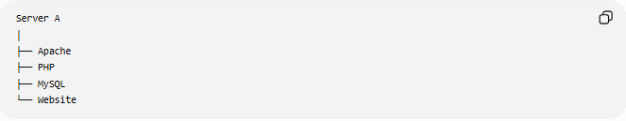
Server A
│
├── Apache
├── PHP
├── MySQL
└── Website
Problems:
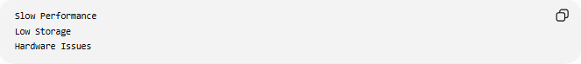
Slow Performance
Low Storage
Hardware Issues

Migration
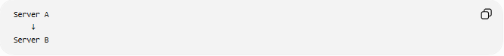
Server A
↓
Server B

After Migration
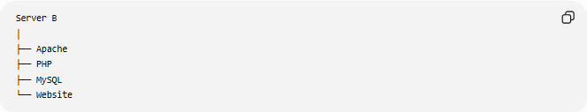
Server B
│
├── Apache
├── PHP
├── MySQL
└── Website
Benefits:
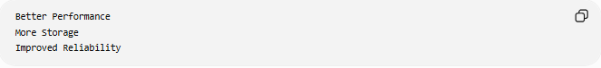
Better Performance
More Storage
Improved Reliability

🔄 Server Migration Lifecycle
# Source: AI Source: Provided by: [Data Path: Persons Table -> ID Column: 1, Name_En Column: Motasem Essam] -> From: [ChatGPT] on [6/7/2026]
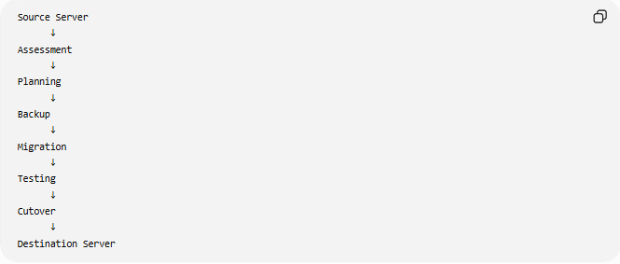
Source Server
↓
Assessment
↓
Planning
↓
Backup
↓
Migration
↓
Testing
↓
Cutover
↓
Destination Server

📦 Components Commonly Migrated
# Source: AI Source: Provided by: [Data Path: Persons Table -> ID Column: 1, Name_En Column: Motasem Essam] -> From: [ChatGPT] on [6/7/2026]
Applications
Examples:
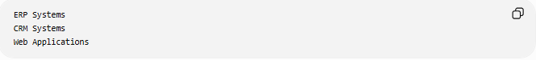
ERP Systems
CRM Systems
Web Applications

Databases
Examples:
- MySQL
- PostgreSQL
- Microsoft SQL Server

Files
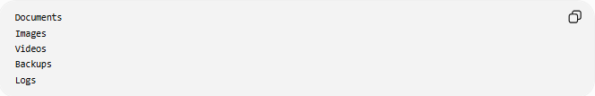
Documents
Images
Videos
Backups
Logs

Services
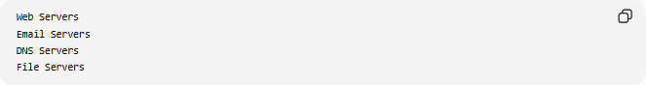
Web Servers
Email Servers
DNS Servers
File Servers

Security Configurations
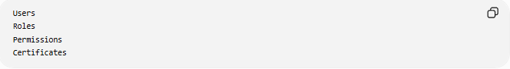
Users
Roles
Permissions
Certificates

🌍 Example Architecture
# Source: AI Source: Provided by: [Data Path: Persons Table -> ID Column: 1, Name_En Column: Motasem Essam] -> From: [ChatGPT] on [6/7/2026]
Before
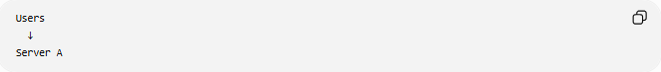
Users
↓
Server A

After
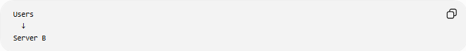
Users
↓
Server B
The users continue using the same application, but the underlying server has changed.

⚠️ Common Challenges
# Source: AI Source: Provided by: [Data Path: Persons Table -> ID Column: 1, Name_En Column: Motasem Essam] -> From: [ChatGPT] on [6/7/2026]
Downtime
Applications may need temporary maintenance windows.

Data Integrity
All data must remain consistent after migration.

Compatibility Issues
Different servers may have:
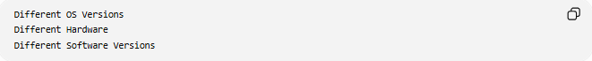
Different OS Versions
Different Hardware
Different Software Versions

Network Changes
Updates may be required for:
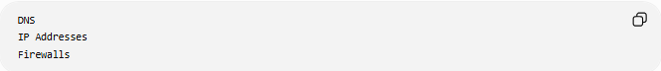
DNS
IP Addresses
Firewalls

Performance Tuning
The new environment may require optimization.

✅ Benefits
# Source: AI Source: Provided by: [Data Path: Persons Table -> ID Column: 1, Name_En Column: Motasem Essam] -> From: [ChatGPT] on [6/7/2026]
Better Performance
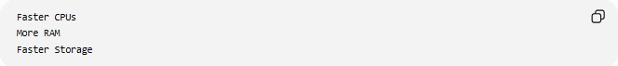
Faster CPUs
More RAM
Faster Storage

Increased Capacity
More Users
More Data

Improved Reliability
Modern Hardware
Better Infrastructure

Enhanced Security
Updated Systems
New Security Controls

Scalability
Grow Resources
As Needed

📊 Server-to-Server vs Server Migration Types
# Source: AI Source: Provided by: [Data Path: Persons Table -> ID Column: 1, Name_En Column: Motasem Essam] -> From: [ChatGPT] on [6/7/2026]
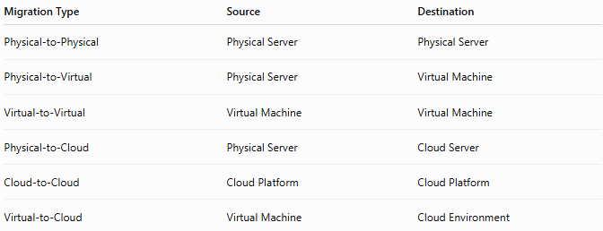
Migration Type | Source | Destination
Physical-to-Physical | Physical Server | Physical Server
Physical-to-Virtual | Physical Server | Virtual Machine
Virtual-to-Virtual | Virtual Machine | Virtual Machine
Physical-to-Cloud | Physical Server | Cloud Server
Cloud-to-Cloud | Cloud Platform | Cloud Platform
Virtual-to-Cloud | Virtual Machine | Cloud Environment

🛠️ Common Migration Tools
# Source: AI Source: Provided by: [Data Path: Persons Table -> ID Column: 1, Name_En Column: Motasem Essam] -> From: [ChatGPT] on [6/7/2026]
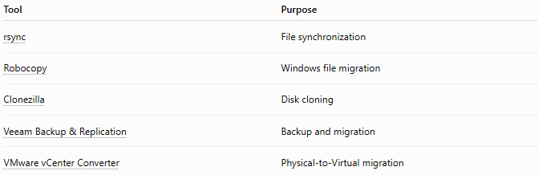
Tool | Purpose
rsync | File synchronization
Robocopy | Windows file migration
Clonezilla | Disk cloning
Veeam Backup & Replication | Backup and migration
VMware vCenter Converter | Physical-to-Virtual migration

🧠 Simple Analogy
# Source: AI Source: Provided by: [Data Path: Persons Table -> ID Column: 1, Name_En Column: Motasem Essam] -> From: [ChatGPT] on [6/7/2026]
Imagine moving a business.
Before
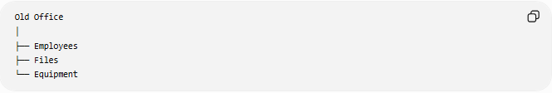
Old Office
│
├── Employees
├── Files
└── Equipment

Migration
Move Everything

After
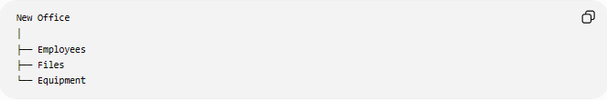
New Office
│
├── Employees
├── Files
└── Equipment
The business remains the same, but it operates from a new location.
Server-to-server migration works similarly:
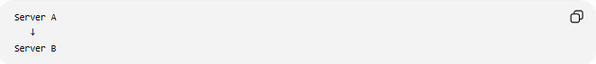
Server A
↓
Server B
while preserving applications, data, and services.

🧭 Summary
# Source: AI Source: Provided by: [Data Path: Persons Table -> ID Column: 1, Name_En Column: Motasem Essam] -> From: [ChatGPT] on [6/7/2026]
Server-to-Server Migration is a general type of server migration that involves moving workloads, applications, databases, files, and configurations from one server to another. It includes migrations such as Physical-to-Physical, Physical-to-Virtual, Virtual-to-Virtual, Physical-to-Cloud, and Cloud-to-Cloud. The goal is to improve performance, scalability, reliability, and infrastructure efficiency while maintaining application availability and functionality.

